|  |
| --- |
| **National University of Computer and Emerging Sciences** |
| Lab Manual  “Introduction to Data Modeling Tutorial Using Erwin” |
|  |
| Database Systems |
| Spring 2018 |

Department of Computer Science

FAST-NU, Lahore, Pakistan

**Table of Contents**

1 Objective 2

2 Task Distribution 2

3 Introduction 3

4 Creation of a basic data model 3

5 Creating an Entity 5

6 Adding primary key columns 7

7 Creating Relationships 10

7.1 One-to-many Relationships 11

8 Generate a Data Dictionary Using Erwin 14

References 17

# Objective

The object of this manual is to give an overview and hands on practice to Data modeling using ERWIN

# Task Distribution

|  |  |
| --- | --- |
| Total Time | 20 Minutes |
| Demo and pracitce | 20 Minutes |

# Introduction

ERwin is a popular data modeling tool. The product supports a variety of aspects of database design, including data modeling, forward engineering (the creation of a database schema and physical database on the basis of a data model), and reverse engineering (the creation of a data model on the basis of an existing database) for a wide variety of relational DBMS. This brief tutorial steps you through the process of creating a data model using Er*win*. Creation of a basic data model (Conceptual data model)

# Creation of a basic data model

The Entities involved in this model include:  Employee, Department.

From the File Menu choose to create a new model: File->New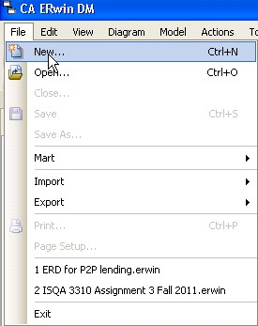  
**Figure 1: Create a new model**

The next dialog box, shown in Figure 2, will ask you to choose the template to be used to create the new model. Choose Logical/Physical as the new model type.  This choice will allow us to switch back and forth easily between a logical model (ER Diagram) and a physical model (database schema).

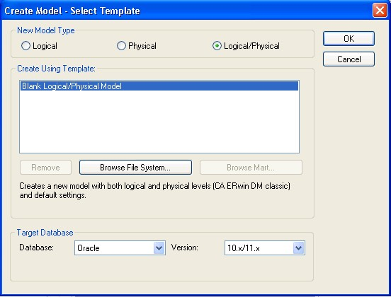  
**Figure 2: Selecting a model type**

ERwin will now display the main window from which most of your ER diagram development will be done, as shown in Figure 3.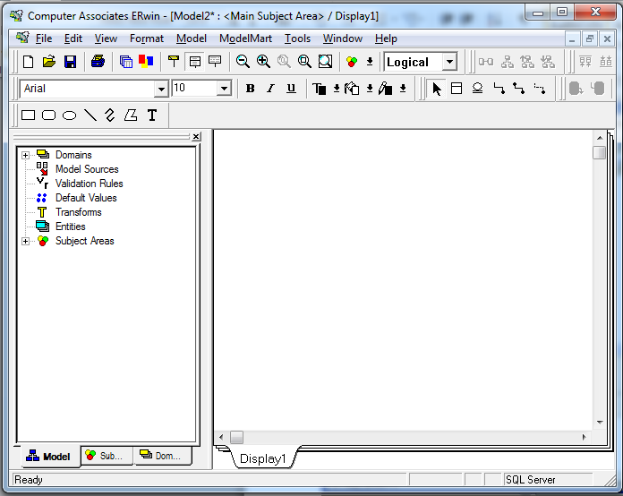  
**Figure 3: The ERwin Workplace**

The ERwin workplace consists of two main parts.  On the left is the Model Navigator, which displays a hierarchy of items of importance, such as entities, domains, and subject areas.   On the right is the Display Window, which will show the ER diagram itself.  As you create objects, they will appear in the display window (if they are visual in nature, like entities), and appear in the hierarchy within the Model Navigator.

# Creating an Entity

To create a new entity, click on the entity icon (http://www.isqa.unomaha.edu/wolcott/tutorials/erwin/erwin_files/04_EntityIcon.jpg) on the toolbar, or right-click on the word *Entity* in the Model Navigator.  If you click on the entity icon, you then should click on the Display Window where you would like the entity to appear, as shown in Figure 4.

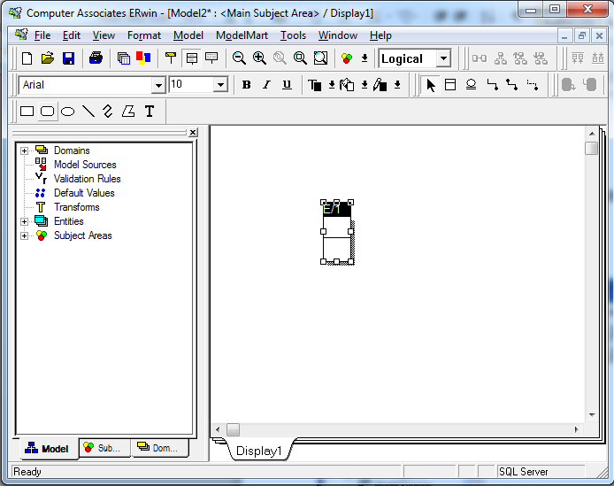  
**Figure 4: A new entity**

Notice that the default name for the entity is E/x, where x is some number (1 in this case).  Click on the *Tab* key several times and notice what happens.  Pressing the *tab* key cause the focus to cycle between the three main parts of the Entity:   the name of the entity, the primary key attribute(s), and the non-primary key attribute(s).   In general, to modify one of these three parts of the entity, you will press the *Tab* key to cycle to the appropriate part of the entity, then type to add or modify that part of the entity.

Right now, press the *Tab* key until the entity name is highlighted.  Then type EMPLOYEE, as shown in Figure 5.

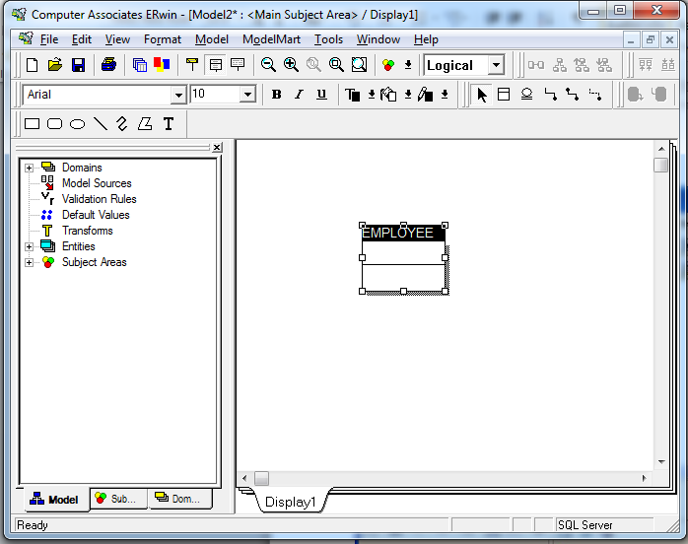  
**Figure 5: Changing the name of the entity**

At this point, you may wish to save and name your diagram to avoid loss should the system or application crash.

# Adding primary key columns

Once you have changed the name to EMPLOYEE, press the *Tab* key again to move the focus to the next part of the Entity, adding a primary key attribute.  Then type the name of the primary key attribute, **id**, as shown in Figure 6.

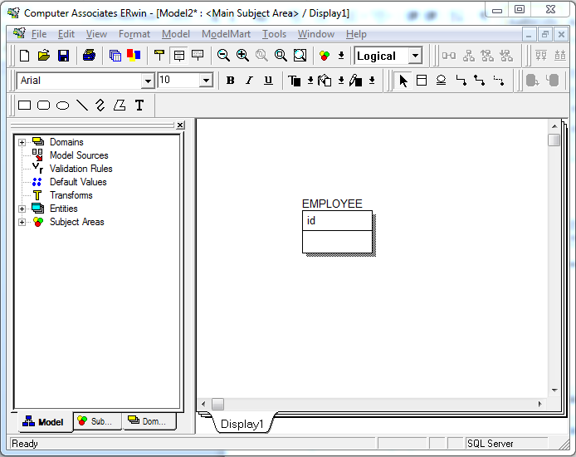  
**Figure 6: Adding a primary key attribute**

Press the *Tab* key one more time to bring the focus below the horizontal line in the Entity, where you will add in a number of non-primary key attributes.   Type fname, as shown in Figure 7.   When you have typed fname, press the *Enter* key (not *Tab*).   Notice what happens.  The cursor is now positioned for you to add another attribute in this same portion of the Entity, the non-primary key attribute portion.  Type another attribute lname.

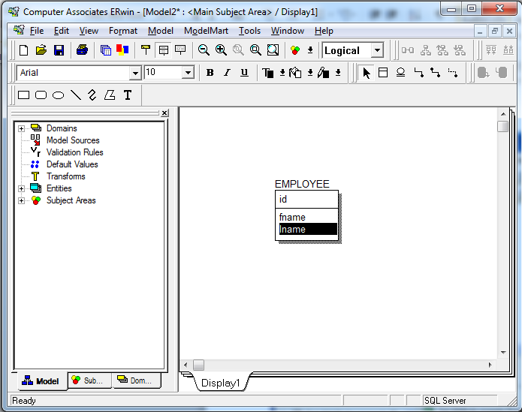  
**Figure 7: Adding non-primary key attributes**

Make another entity, DEPARTMET with primary key dept_id and attributes name and citys shown in the figure below.

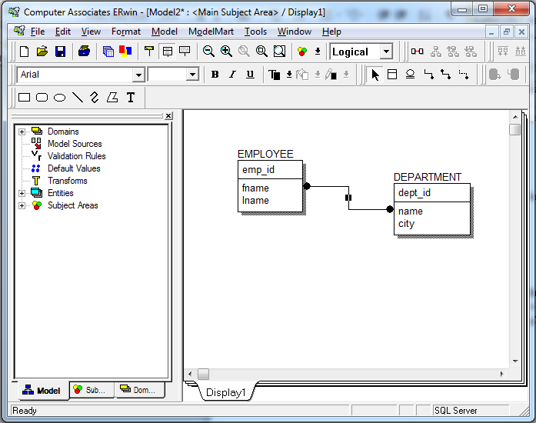

**Figure 8: The Employee entity**

# Creating Relationships

ER*win* supports the creation of relationships with three basic kinds of connectivity:   one-to-one, one-to-many, and many-to-many.  Within the one-to-many category, ER*win* allows us to distinguish between *identifying* and *non-identifying* one-to-many relationships.

**Q:** [What's the difference between identifying and non-identifying relationships?](http://stackoverflow.com/questions/762937/whats-the-difference-between-identifying-and-non-identifying-relationships)

* An **identifying relationship** is when the existence of a row in a child table depends on a row in a parent table. This may be confusing because it's common practice these days to create a pseudokey for a child table, but *not* make the foreign key to the parent part of the child's primary key. Formally, the "right" way to do this is to make the foreign key part of the child's primary key. But the logical relationship is that the child cannot exist without the parent.

**Example**: A Person has one or more phone numbers. If they had just one phone number, we could simply store it in a column of Person. Since we want to support multiple phone numbers, we make a second table PhoneNumbers, whose primary key includes the person_id referencing the Person table.

We may think of the phone number(s) as belonging to a person, even though they are modeled as attributes of a separate table. This is a strong clue that this is an identifying relationship (even if we don't literally include person_id in the primary key of PhoneNumbers).

* A **non-identifying relationship** is when the primary key attributes of the parent *must not* become primary key attributes of the child. A good example of this is a lookup table, such as a foreign key onPerson.state referencing the primary key of States.state. Person is a child table with respect to States. But a row in Person is not identified by its state attribute. I.e. state is not part of the primary key of Person.

A non-identifying relationship can be **optional** or **mandatory**, which means the foreign key column allows NULL or disallows NULL, respectively.

## One-to-many Relationships

An *non-identifying* relationship is created by clicking first on the non-identifying relationship icon ().  To create an *non-identifying* relationship, click first on this icon, then click on the parent entity (on the one side of the relationship) and then click on the child entity (on the many side of the relationship).   In this case, you will click first on the *non-identifying* relationship icon, then on DEPARTMENT, then on EMPLOYEE.  The results are shown in Figure 10.

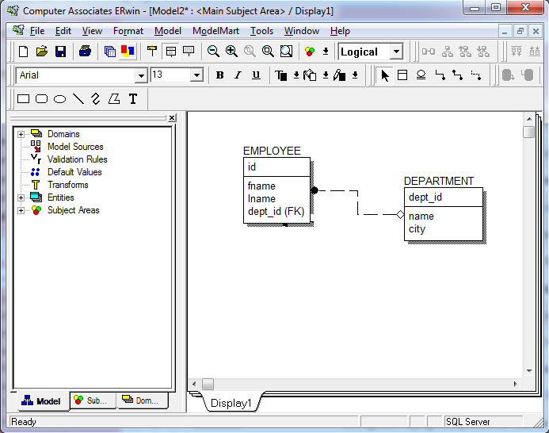  
**Figure 10: A non-identifying relationship**

Double-click on the relationship itself to bring up a dialog box in which we can further refine the relationship definition.   As shown in Figure 11.

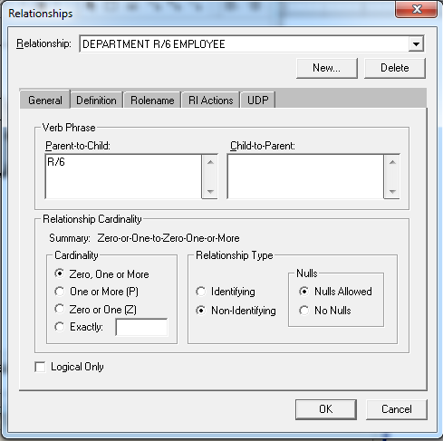  
**Figure 11: Relationships definition**

In the Relationship Cardinality portion of this window, we can determine how many child entity occurrences may be associated with each parent entity occurrence.

You can further inquire about the functionality of Erwin By going though the guide guide provided in Lab 6 folder.

# Generate a Data Dictionary Using Erwin

Switch to logical view. Go to the Tools menu, choose Report Builder. Until the first template is saved in the Reports folder, you may see a message indicating that the folder is empty. Or you may see a message indicating that you need to click the Browse button on the next dialog and select a folder where you want to save your reports.

Click new to create a new report.

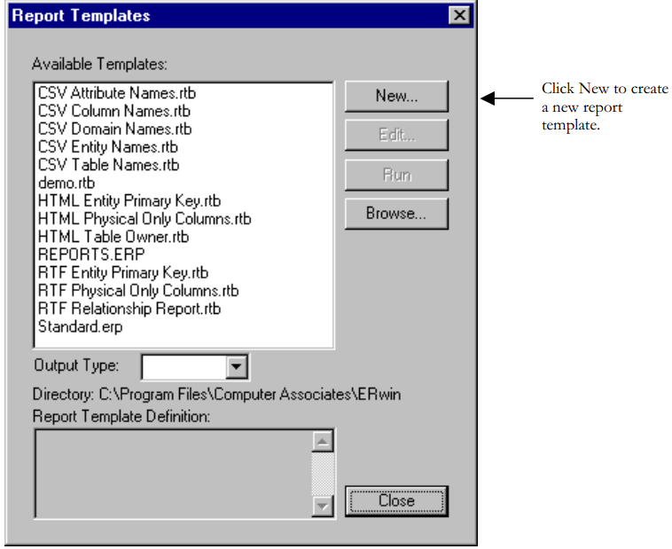

The dialog box as shown in figure 12 will pop up.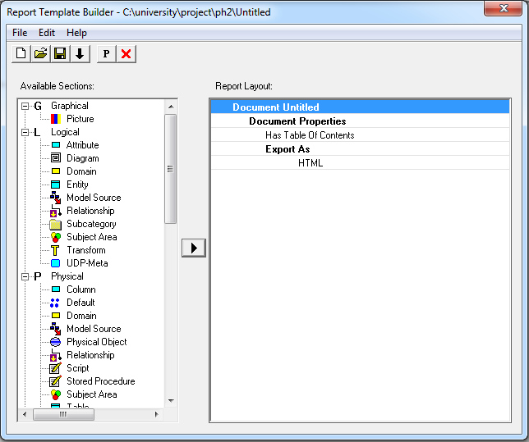

**Figure 12: report template builder**

You can select various options to build a report template which, can be explored in detail in the Erwin guide provided. You can export the document as HTML, RTF or text.

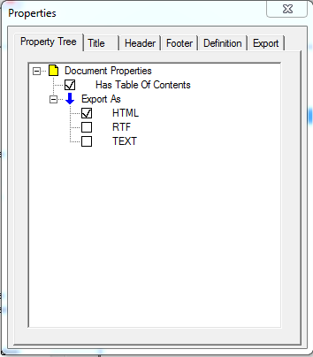

Select the Entity section from the right panel. We created two entities in the last section. We want to generate the data dictionaries for Data Model we created in the last section. Select the table and diagram sections from the right panel as shown in figure below.

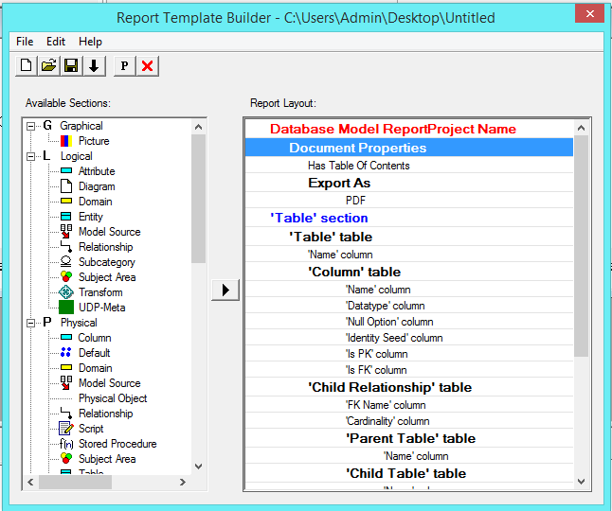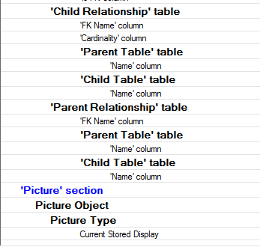

Now, Save your report template. Close the report template builder window.

Select the template you just created and click run to generate the data dictionary as Shown in the figure below.

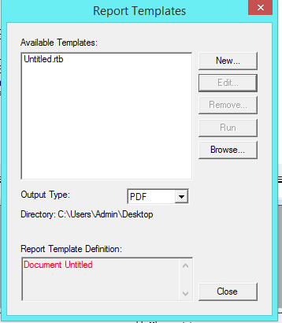

Select Output tye as PDF. After clicking run, the generated report will get displayed as shown in file Reprt.PDF .

# References

* <http://www.isqa.unomaha.edu/wolcott/tutorials/erwin/erwin.html>
* http://stackoverflow.com/questions/762937/whats-the-difference-between-identifying-and-non-identifying-relationships